
Course: Selected Topic 2 (Big Data)
Instructors: Prof. Tarek Gharib & Dr. Sherine Rady
Student Name: Ahmed Khaled Moawed
ID:2017170575 Assignment due date: 4/6/2021

Assignment: Data Visualization using R
Version D

- Plot 1:
Observation : Education Level = 6 It has the highest Salary.
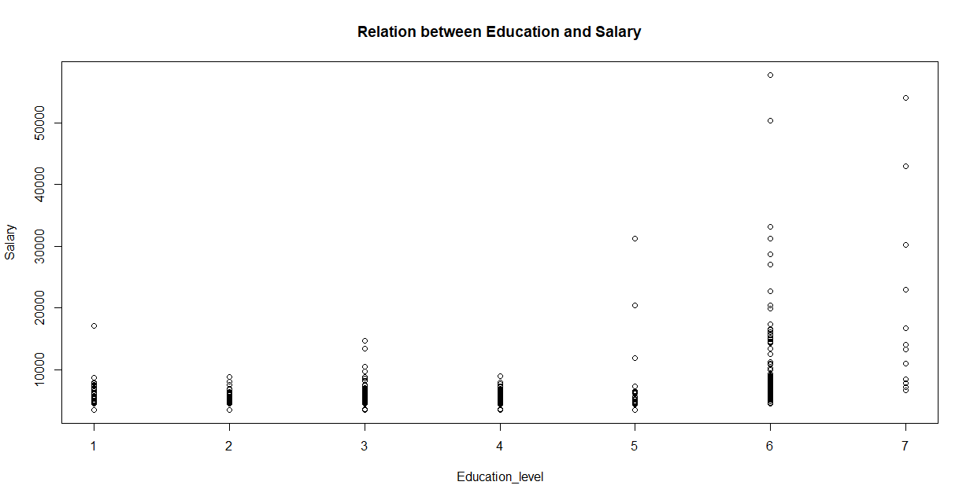

- Plot 2: Observation, There is a number between 0 and 5 that has the highest frequency in the company
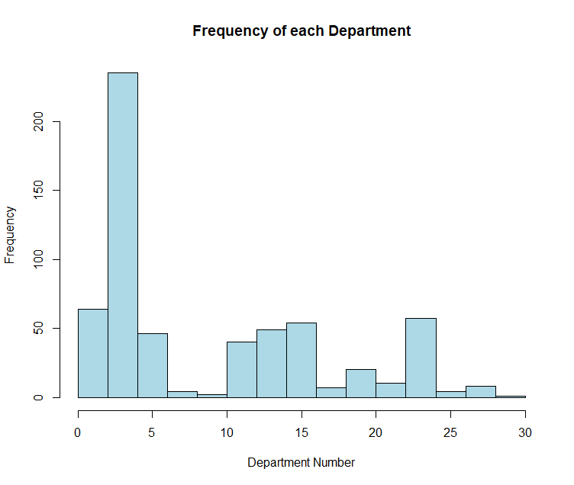

- Plot 3:
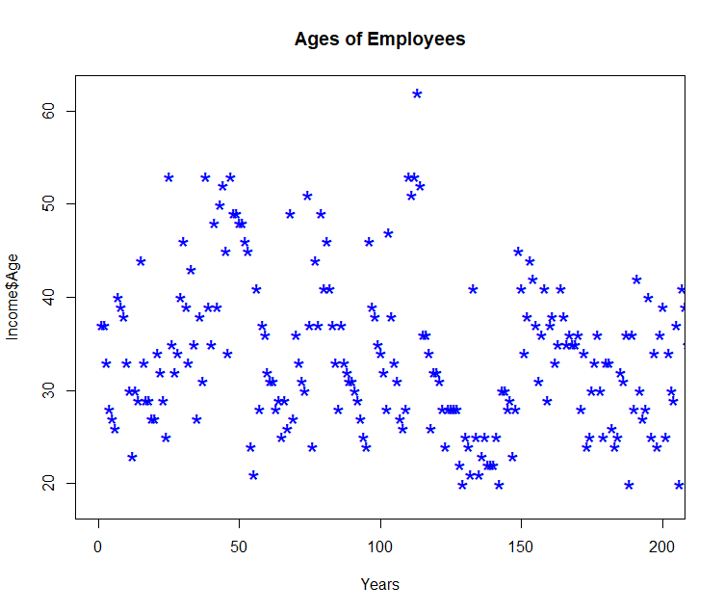
- Plot 4:
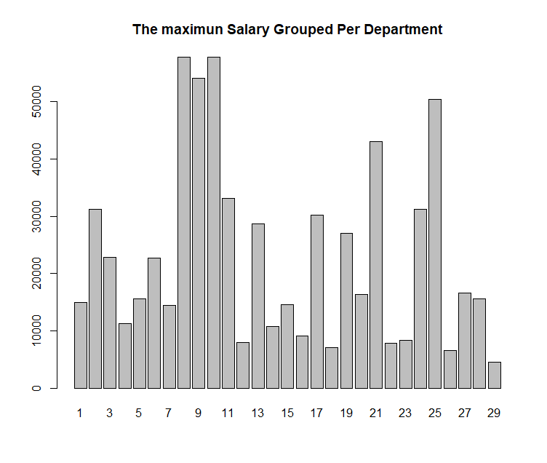

- Plot 5:
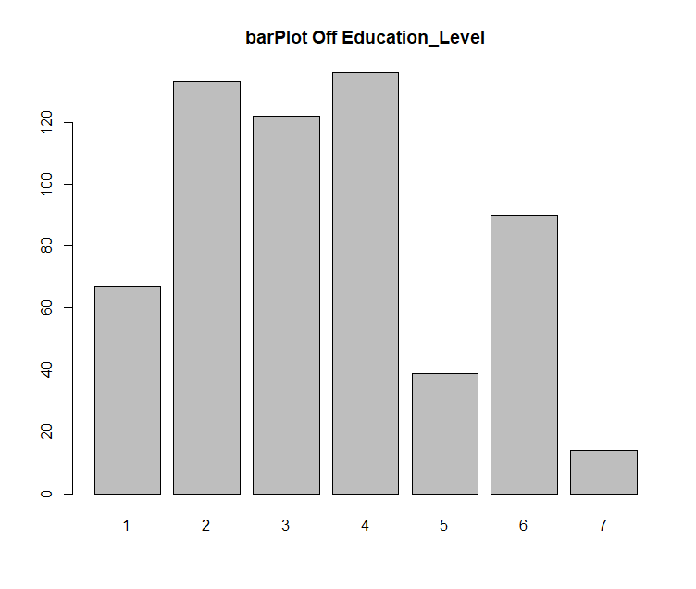
- Plot 6:
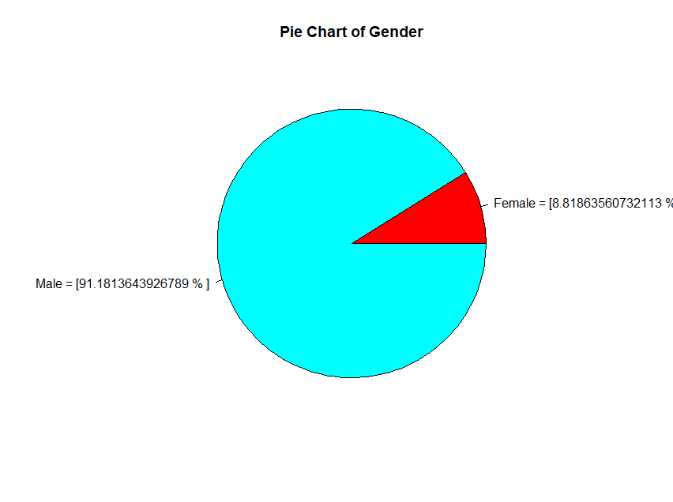

- Plot 7 part1 :
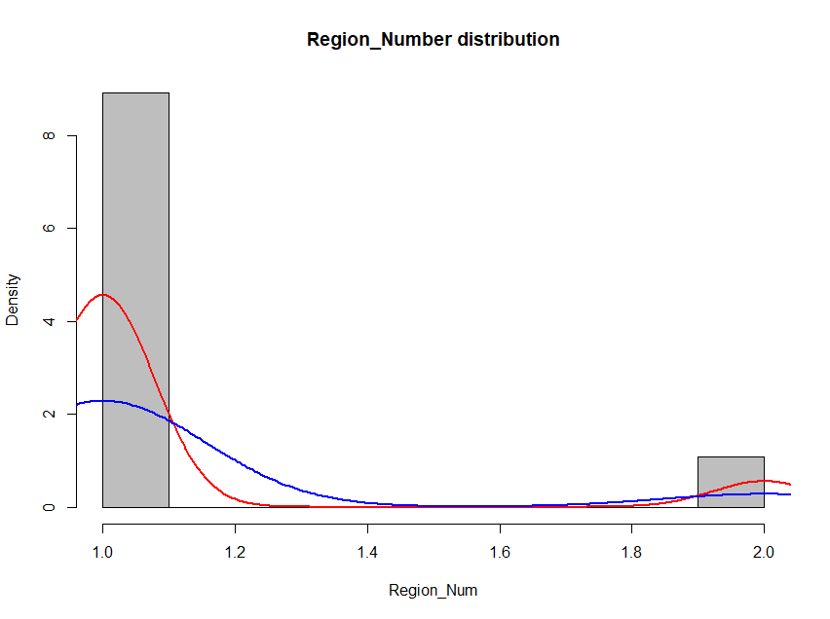

- Plot 7 part2:
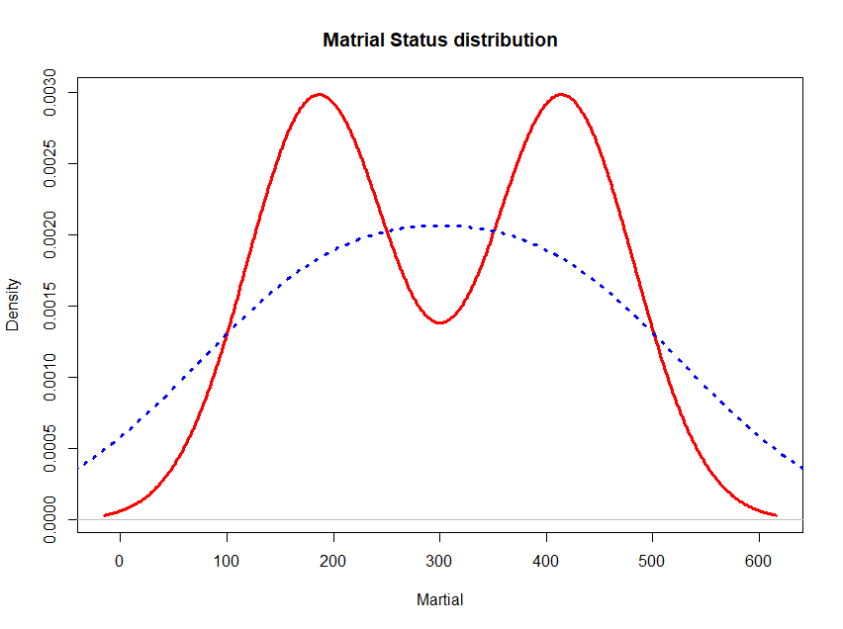

- Plot 8:
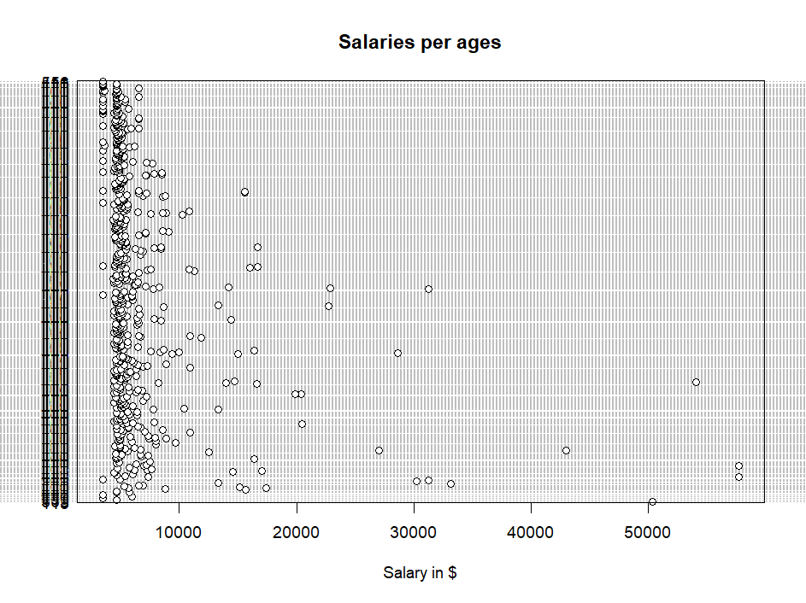

- Plot 9:
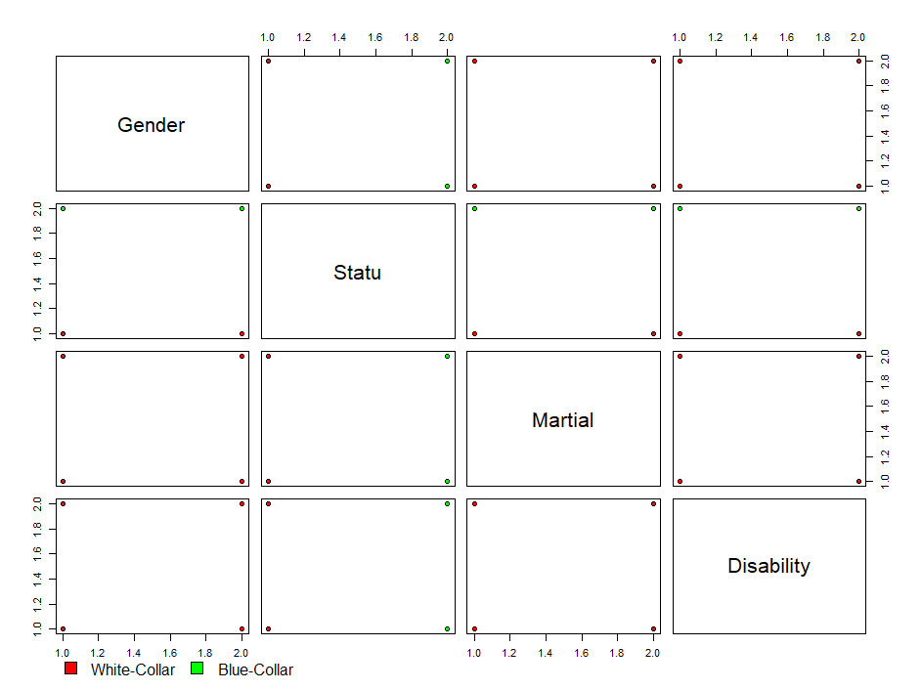
- Plot 10:
